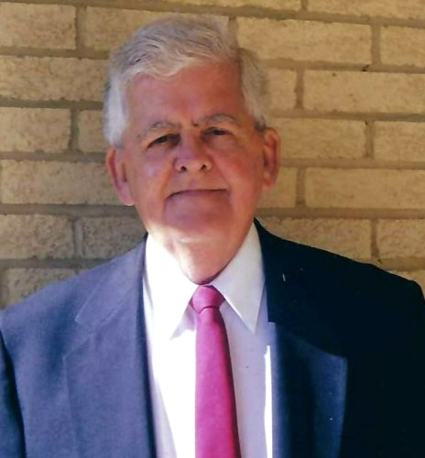

Robert Dickinson Obituary
Robert Nathaniel Dickinson, 85, of Frederick, Maryland, peacefully passed away on Thursday, December 1, 2022 at Somerford House in Frederick, Maryland with his wife by his side. He was the beloved husband of Joanne H. Dickinson for 60 years.
Born on June 7, 1937 in Midland, Maryland, he was the son of the late John T. Dickinson and Adeline (Moses) Dickinson.
Bob grew up in Lonaconing, Maryland, a place he often spoke of with fondness. He was a member of his high school's drama club and school band, playing the clarinet and violin. Since he was the biggest guy in the band, he was asked if he could learn to play (and carry) the tuba, a challenge he happily accepted. He was voted the top musician in his graduating class of Valley High '55.
After high school Bob accepted a job with AT&T. He worked in Baltimore, Maryland and would carpool home to Lonaconing on weekends to be with his girlfriend, Joanne. In 1958 he joined the Army and was stationed at Fort Huachuca in southeast Arizona until 1960. While there he learned skills that would help with his career at AT&T, which counted his time in the Army as time worked for them.
Bob moved to Frederick, Maryland and married Joanne on June 23, 1962. Two children soon came along. He continued to rise within AT&T, working in Frederick, Monrovia, Md., Washington, D.C. and Fairfax, Va. along the way, never missing a day of work in over 30 years. He became 1 of 7 Regional Managers in the U.S., representing the D.C. Metro area, traveling across the country to discuss the latest advances in the industry and relaying that information back to this area. He retired at age 51 in 1989.
In his retirement he volunteered for his church and other charitable organizations.. His proudest time was when he served for 7 years as the manager for the Frederick Food Bank, saying how rewarding it was to be a part of helping so many people. Bob was an avid bridge player, nearing Life Master status. He bowled in leagues for over 40 years, mostly at the old Village Lanes. When they shut down their duck pin bowling alley, he and Joanne took up ten pin bowling while in their 70's. He enjoyed annual trips to Ocean City, and to Florida, where he and Joanne would attend Spring Training baseball games of the Baltimore Orioles. He also loved to watch the birds and animals on his property, and had a great appreciation of the colors of nature. He would light up when his daughter-in-law, Jane, would bring plants and flowers to family occasions.
Bob enjoyed kidding around with anyone who greeted him with a smile, from family to total strangers. He would always thank anyone who helped in any way, the gentlemen getting a firm handshake and the ladies often getting a kiss on the hand.
In addition to his wife, he is survived by his children Robert N. (and his wife, Jane) Dickinson, Jr. and Deanna Steinbrecher. He is also survived by his brother John M. (Jack) Dickinson.
The family would like to thank the staff at Somerford House for the care they provided during his time there. He often mentioned how thankful he was for the help he received from "these wonderful people".
The family will receive friends on Saturday, January 14, 2023 at 1:00 pm at Saint Katharine Drexel Catholic Church, 8428 Opossumtown Pike, Frederick, Maryland.
Memorial donations may be made for Alzheimer's research at BrightFocus.org" target="_new" rel="nofollow">donate.BrightFocus.org.
Expressions of sympathy may be offered to the family at resthaven.us. Robert Nathaniel Dickinson Sr

